Kenya DPA Compliance for Log360
Strengthen data protection and meet Kenya DPA compliance with Log360.
Region: Kenya | Type: Data Privacy | Category: Compliance | Pricing: Free

Overview
The Kenya DPA compliance extension in Log360 helps organizations meet the Data Protection Act No. 24 of 2019 (Kenya), Kenya's first comprehensive data protection law enforced by the Office of the Data Protection Commissioner for all data controllers and processors by providing centralized log management, user access monitoring, and breach detection. The platform supports Kenya DPA requirements for personal data security, breach notification, access control, third-party processor oversight, data localization, retention management, privacy by design, consent management, and data subject rights fulfillment.
For Personal Data Protection Principles, Log360 provides audit trails across databases, Windows, and AD systems to verify that processing activities remain within declared lawful purposes and data minimization obligations. To address Data Subject Rights Fulfillment, the platform monitors user account changes, AD management events, and access logs to trace data subject request handling and verify timely compliance with all rights obligations. The extension also supports Technical and Organizational Security Measures by providing capabilities that monitors logon failures, privilege changes, file access, and policy modifications to enforce data security controls across all platforms and detect security violations.

Key Features
- Personal Data Breach Detection and Notification: Log360 integrates threat detection, antivirus, and network attack reports to detect and document potential personal data breach events for timely notification.
- Consent and Lawful Basis Management: Log360 tracks policy changes, user access events, and administrative activities to maintain an auditable record evidencing lawful data processing compliance across all systems.
- Access Control and Authentication Enforcement: Log360 monitors Windows and Unix logon activity, MFA events, and AD access reports to detect and alert on unauthorized data access attempts across all platforms.
- Third-Party Processor Oversight and Contracts: Log360 monitors vendor access events, network device activity, and cloud integration reports to detect unauthorized third-party data interactions and enforce processor obligations.
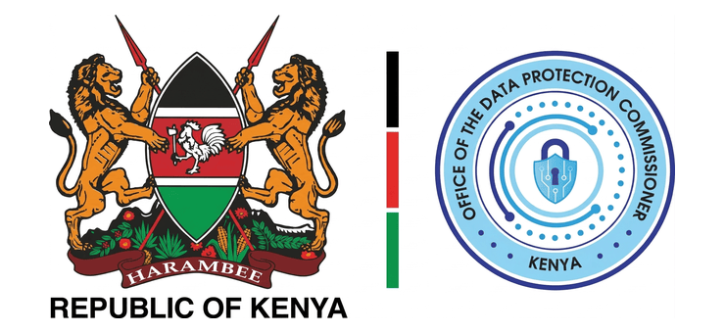

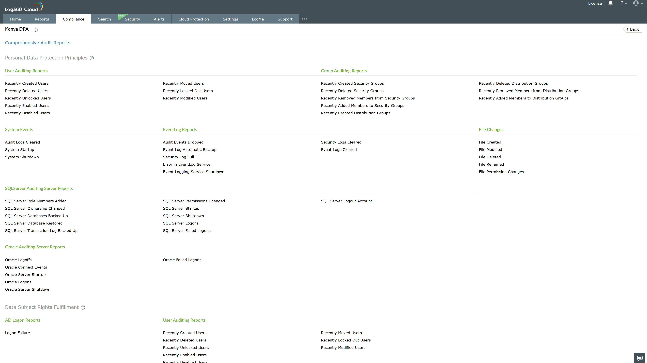
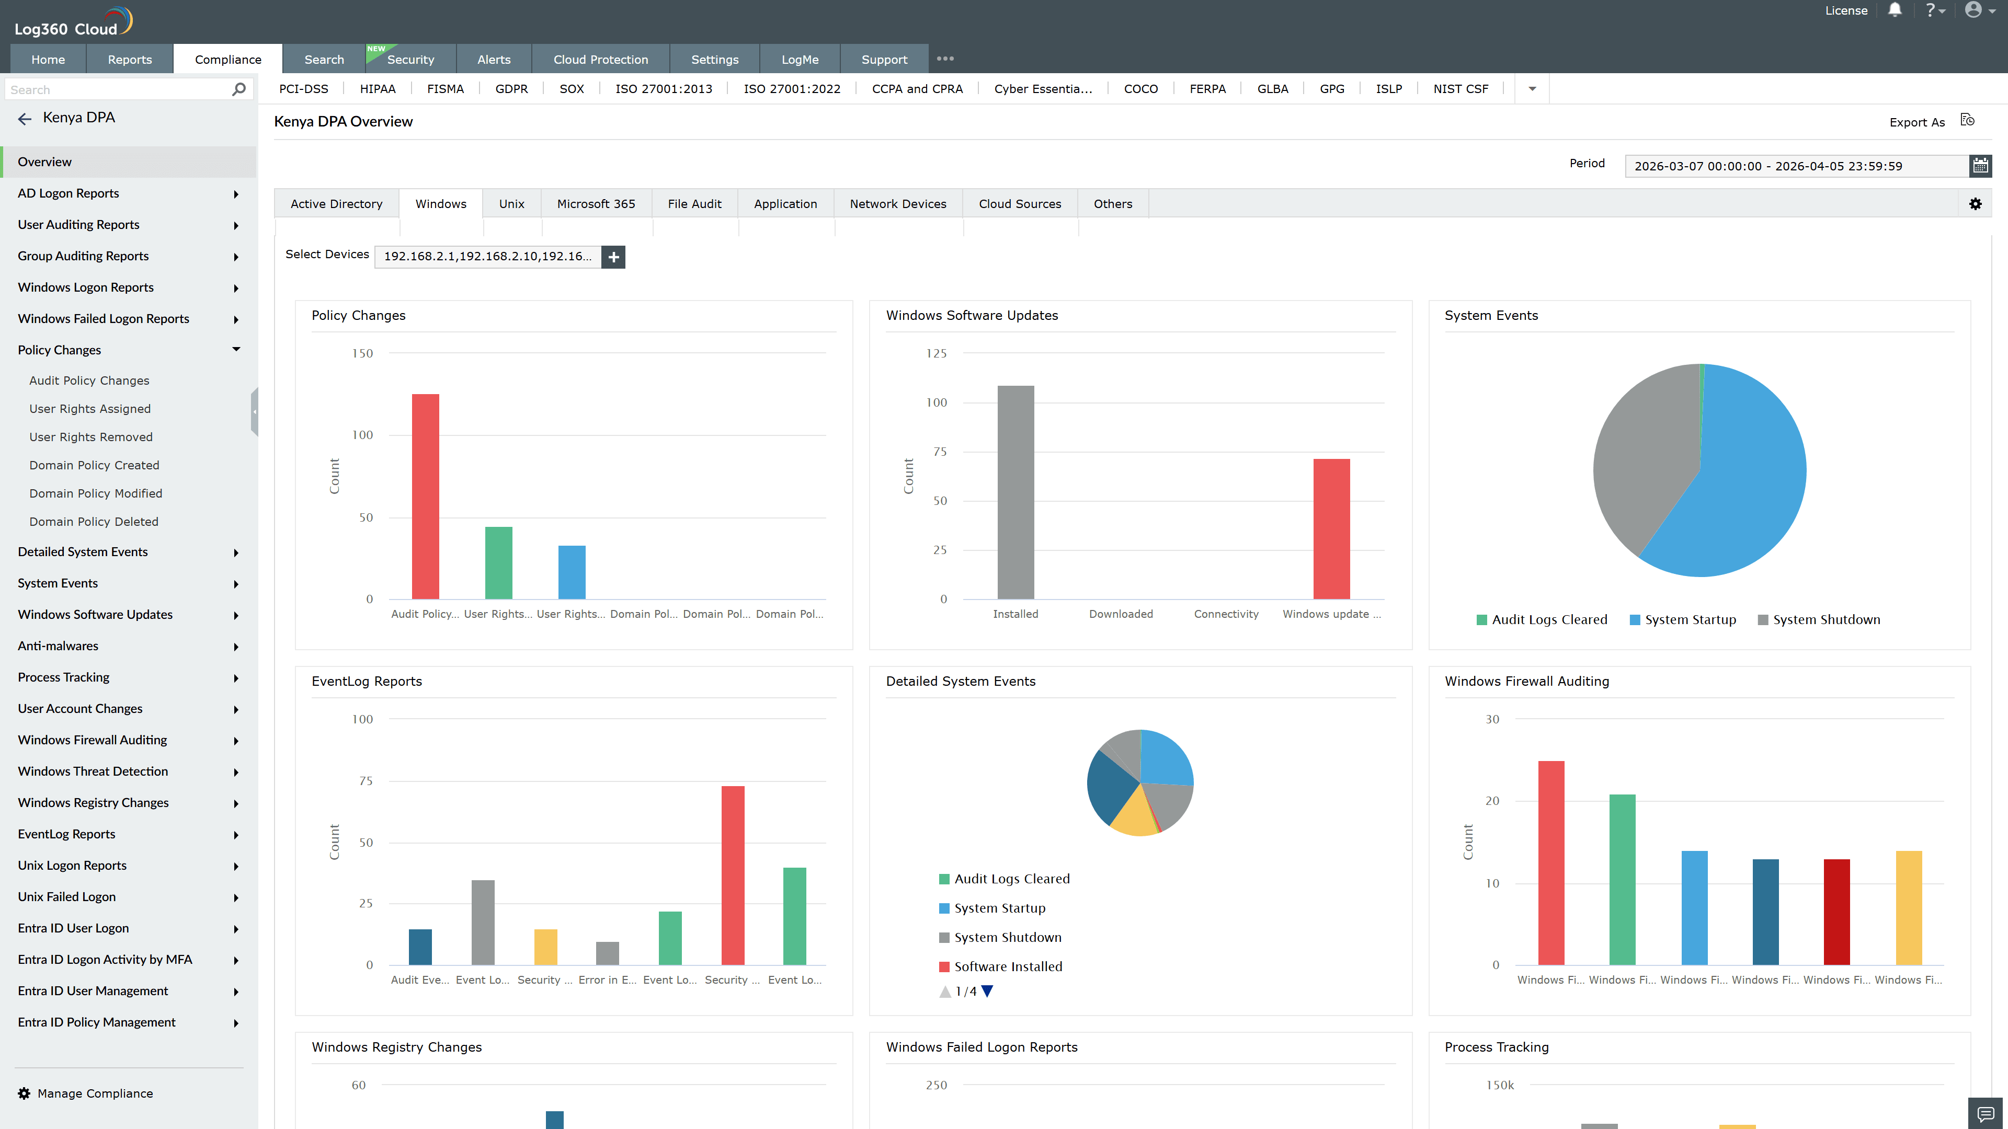
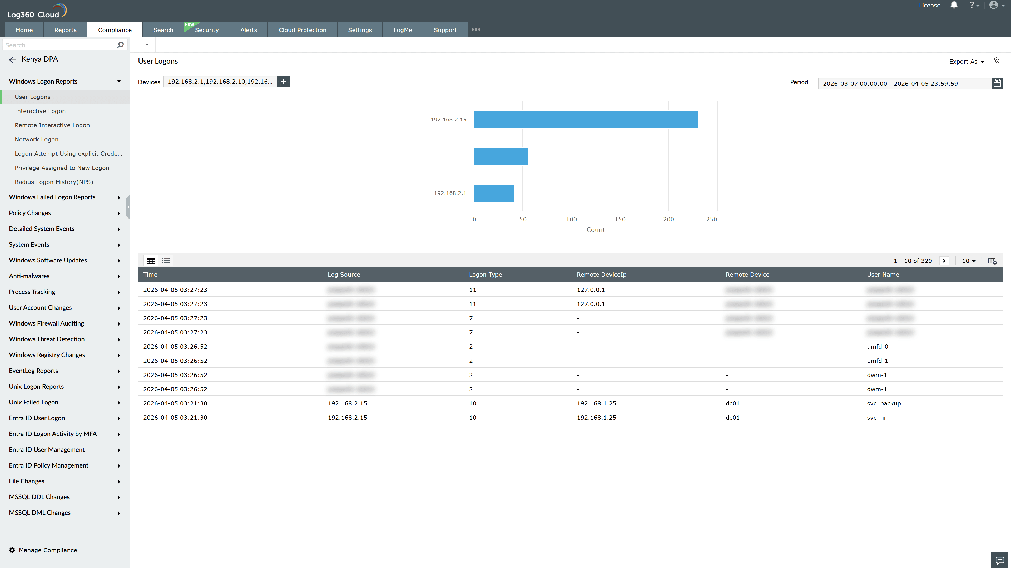
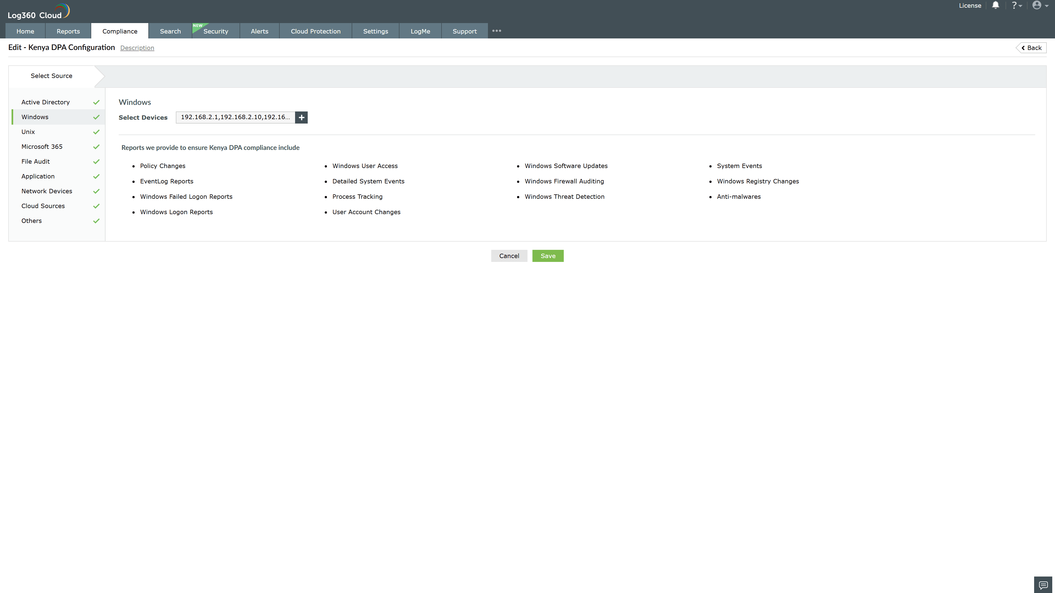
Valid Submission : Yes
Supported Editions : Free, Basic, Standard, Professional, MSSP
Help Document : https://www.manageengine.com/log-management/help/integrations/compliance-extensions.html
Help Video : Not provided
Tags : Log360, Compliance, Privacy monitoring, Data privacy, Regulatory compliance
Supported DCs : US, IN, JP, CA, AU, UK and EU
Privacy Policy:
Terms of Service:
Release Notes:
Predefined reports for the Kenya DPA.

